Preparations

Exercise 2-1, installing gulp

Exercise 2-1, gulp version

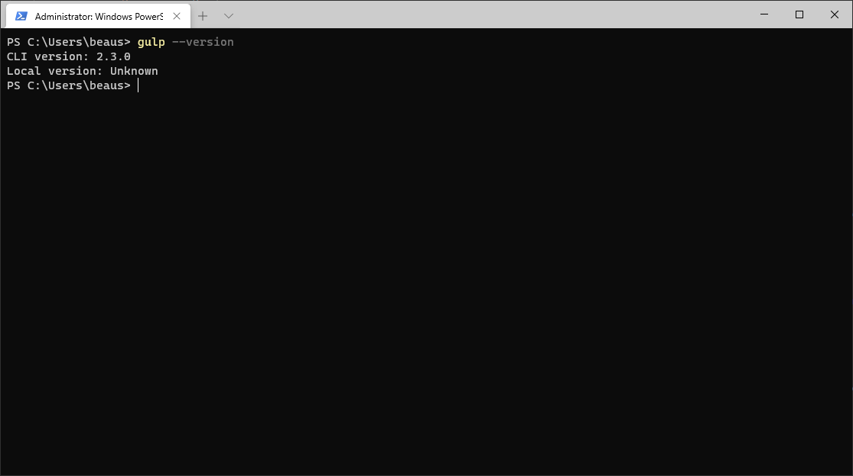

Exercise 2 start of packages

Exercise 2 middle of packages

Exercise 2 end of packages

